**b. Bug:** Player cannot reach betting limit.

**Description:** Game ends although player has remaining balance 5, as limit is 0 player is allowed to play game till 0 balance.

**Reproducing bug:** Program should check that balance is greater than betting amount.

I.e. when player bet’s, program should check if balance – amount is >= limit, but, actually program is checking balance – amount > limit, due to which this bug is occurring.

**Screenshots:**

On running code, firstly all 3 dice gets initialized.

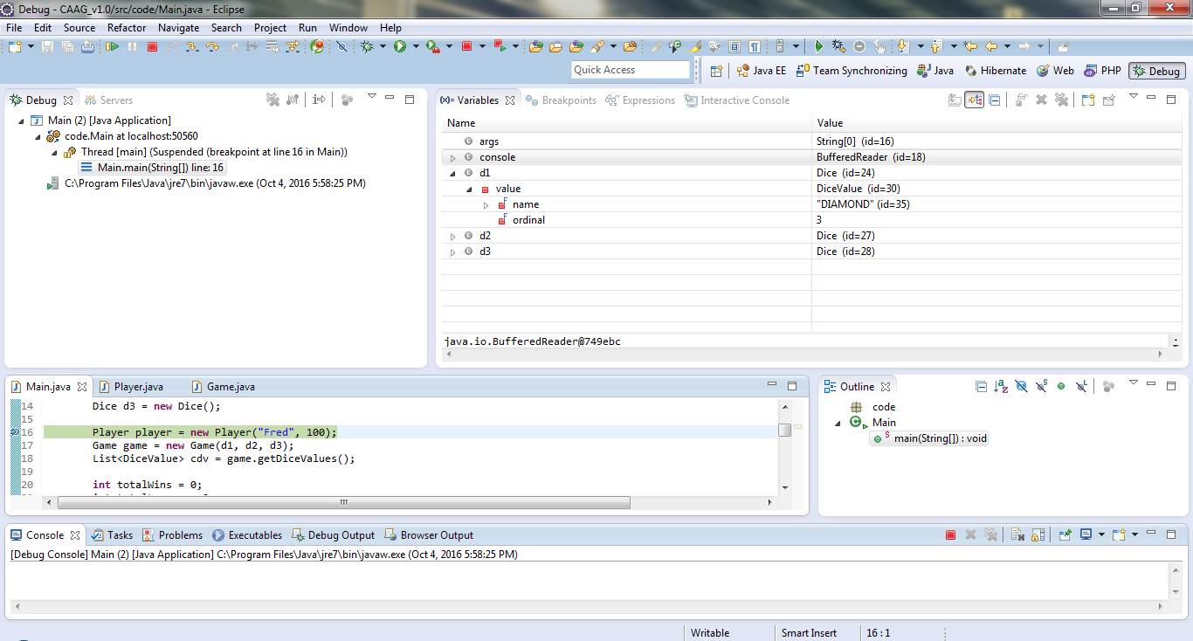

Player’s initial balance and limit set to 100 and 0 respectively, also, see method ‘balanceExceedsLimitBy(int amount)’,

this method return true if ‘balance – amount > limit’ which is the reason for bug.

To resolve bug return true if ‘balance – amount **>=** limit’.

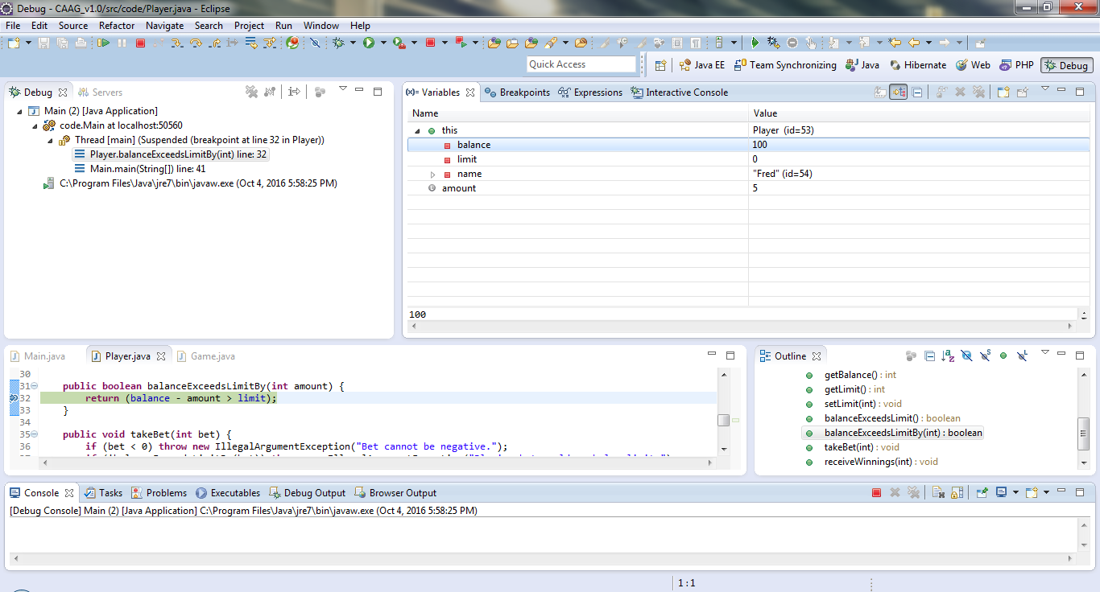

Variable status at turn 19.

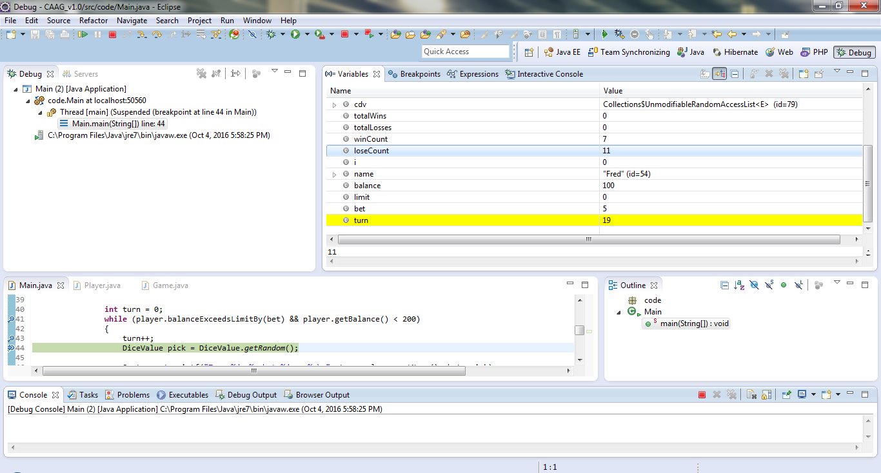

Variable status at turn 40.

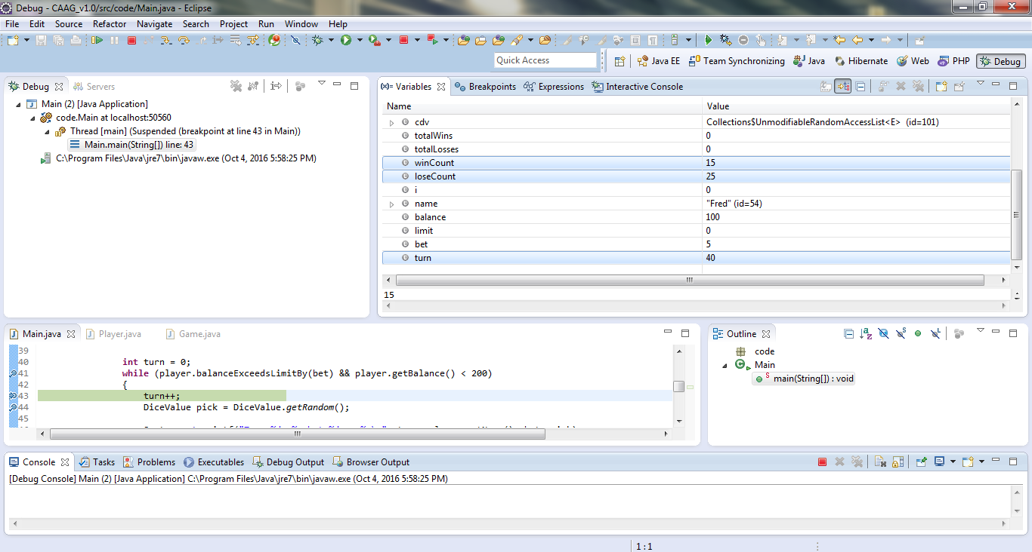

Balance remained 5, limit is 0.

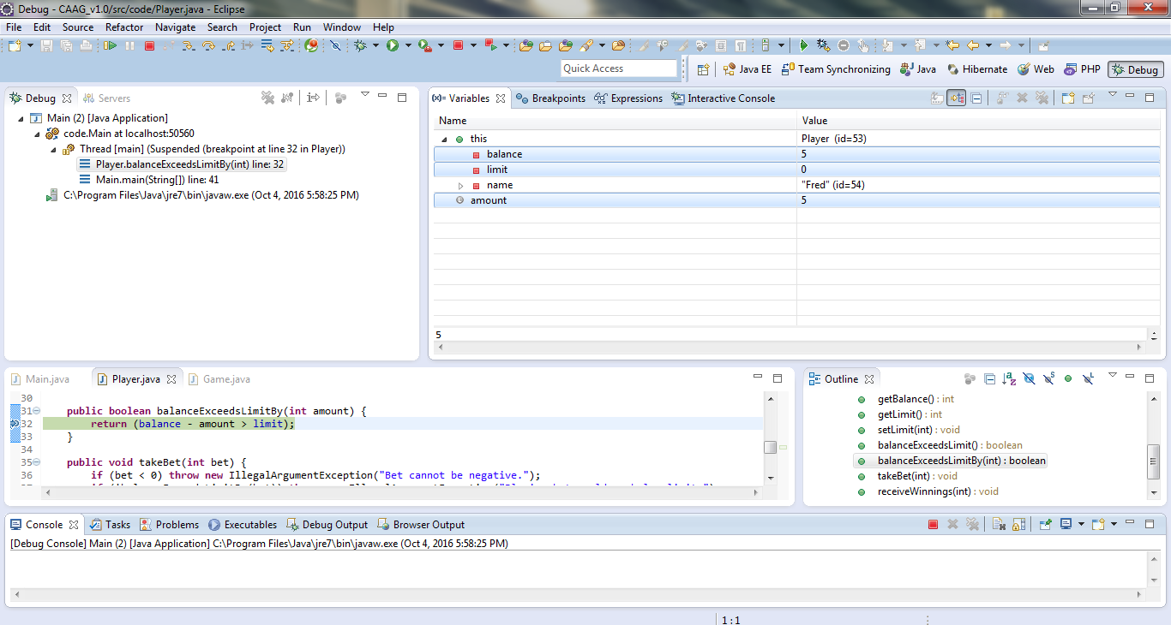

Loop breaks although balance was 5 (previous screenshot).

